HomeWork 2

Wenyuan Shao

Problem 1.

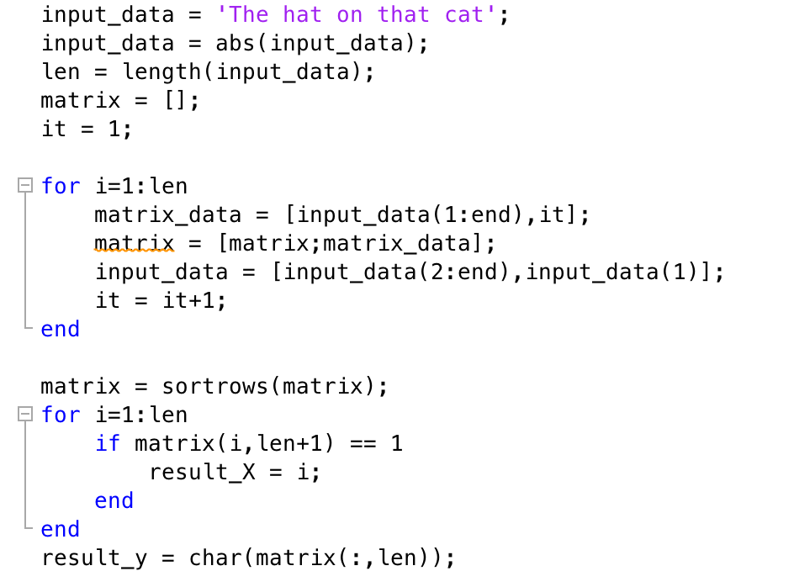

1. Algorithm
   1. If the length of each row is less than the length of the input string, add a column y on the left of the original column;
   2. It sorts the rows of A lexicographically where every row is treated as a word;
   3. Take row L as the final output;
2. The code will be:

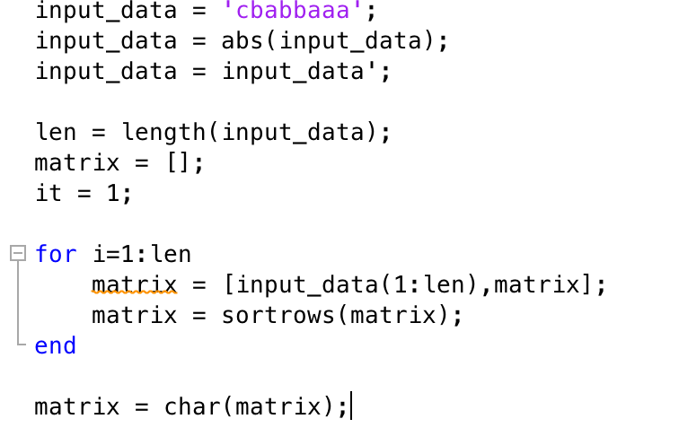

1. Reconstruct:

The input is ‘babacaab’ and the string after the transform is ‘cbabbaaa’. The reconstruct progress will be:



the output is:

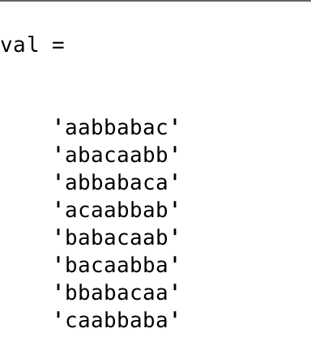

Take the 5th line as the result which is ‘babacaab’.

Problem 2.

Code:

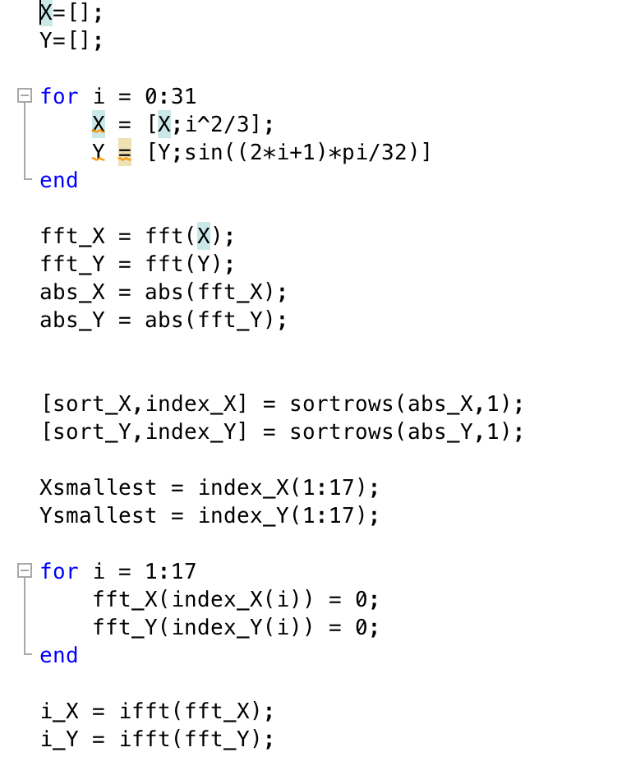

1. X = 3472.00000000000 + 0.00000000000000i

384.463300905693 + 1732.80774615191i

-30.5379073648631 + 857.999273322811i

-107.374421200434 + 562.612600992140i

-134.248388668020 + 412.025781311675i

-146.665874057433 + 319.294875612056i

-153.387579686168 + 255.420716828244i

-157.414662176692 + 207.957935033681i

-160.000000000000 + 170.666666666667i

-161.741260385515 + 140.062513634758i

-162.952198975084 + 114.035820871560i

-163.809588509571 + 91.2232338689351i

-164.418277998646 + 70.6924479783416i

-164.842564210904 + 51.7711673356531i

-165.122313973885 + 33.9477106994615i

-165.281597031812 + 16.8091995062894i

-165.333333333333 + 0.00000000000000i

-165.281597031812 - 16.8091995062894i

-165.122313973885 - 33.9477106994615i

-164.842564210904 - 51.7711673356531i

-164.418277998646 - 70.6924479783416i

-163.809588509571 - 91.2232338689351i

-162.952198975084 - 114.035820871560i

-161.741260385515 - 140.062513634758i

-160.000000000000 - 170.666666666667i

-157.414662176692 - 207.957935033681i

-153.387579686168 - 255.420716828244i

-146.665874057433 - 319.294875612056i

-134.248388668020 - 412.025781311675i

-107.374421200434 - 562.612600992140i

-30.5379073648631 - 857.999273322811i

384.463300905693 - 1732.80774615191i

Y=6.10622663543836e-16 + 0.00000000000000i

1.56827424527297 - 15.9229556267552i

4.38231337323921e-16 - 7.94766685013237e-16i

4.93430825863106e-16 - 4.25378578172991e-16i

2.65361626333167e-16 - 3.63083881070623e-16i

1.07876927046680e-15 - 7.31823213308418e-17i

4.71780225305545e-16 + 7.22688828477049e-16i

5.62430208535118e-16 + 6.08831174113916e-16i

-2.08166817117217e-16 + 4.85722573273506e-16i

-1.00651941838518e-15 + 6.08831174113916e-16i

-1.30006157953161e-16 - 2.95560309336384e-16i

3.14537541583566e-17 - 2.95226926255873e-16i

2.06483159132525e-16 - 3.63083881070623e-16i

6.16792198762051e-16 + 2.40755236602103e-16i

-7.24494253445047e-16 + 8.51519436273706e-16i

4.44089209850063e-16 + -0.00000000000000i

-1.02695629777827e-15 + 0.00000000000000i

4.44089209850063e-16 + 0.00000000000000i

-7.24494253445047e-16 - 8.51519436273706e-16i

6.16792198762051e-16 - 2.40755236602103e-16i

2.06483159132525e-16 + 3.63083881070623e-16i

3.14537541583566e-17 + 2.95226926255873e-16i

-1.30006157953161e-16 + 2.95560309336384e-16i

-1.00651941838518e-15 - 6.08831174113916e-16i

-2.08166817117217e-16 - 4.85722573273506e-16i

5.62430208535118e-16 - 6.08831174113916e-16i

4.71780225305545e-16 - 7.22688828477049e-16i

1.07876927046680e-15 + 7.31823213308418e-17i

2.65361626333167e-16 + 3.63083881070623e-16i

4.93430825863106e-16 + 4.25378578172991e-16i

4.38231337323921e-16 + 7.94766685013237e-16i

1.56827424527297 + 15.9229556267552i

1. abs_X = 3472

1774.94639774484

858.542553871791

572.767147384755

433.344983039444

351.368889068382

297.938738983426

260.817711460849

233.938263460921

213.957339291695

198.890893689646

187.497359141886

178.971484715333

172.781146954528

168.575875005365

166.134149124822

165.333333333333

166.134149124822

168.575875005365

172.781146954528

178.971484715333

187.497359141886

198.890893689646

213.957339291695

233.938263460921

260.817711460849

297.938738983426

351.368889068382

433.344983039444

572.767147384755

858.542553871791

1774.94639774484

abs_y = 6.10622663543836e-16

16

9.07579632109294e-16

6.51475950960910e-16

4.49718464623690e-16

1.08124871840795e-15

8.63050244073240e-16

8.28856524403220e-16

5.28450415778197e-16

1.17633189966071e-15

3.22889296138415e-16

2.96897754516846e-16

4.17690315543291e-16

6.62114567431543e-16

1.11802382516062e-15

4.44089209850063e-16

1.02695629777827e-15

4.44089209850063e-16

1.11802382516062e-15

6.62114567431543e-16

4.17690315543291e-16

2.96897754516846e-16

3.22889296138415e-16

1.17633189966071e-15

5.28450415778197e-16

8.28856524403220e-16

8.63050244073240e-16

1.08124871840795e-15

4.49718464623690e-16

6.51475950960910e-16

9.07579632109294e-16

16

1. X = 3472.00000000000 + 0.00000000000000i

384.463300905693 + 1732.80774615191i

-30.5379073648631 + 857.999273322811i

-107.374421200434 + 562.612600992140i

-134.248388668020 + 412.025781311675i

-146.665874057433 + 319.294875612056i

-153.387579686168 + 255.420716828244i

-157.414662176692 + 207.957935033681i

0.00000000000000 + 0.00000000000000i

0.00000000000000 + 0.00000000000000i

0.00000000000000 + 0.00000000000000i

0.00000000000000 + 0.00000000000000i

0.00000000000000 + 0.00000000000000i

0.00000000000000 + 0.00000000000000i

0.00000000000000 + 0.00000000000000i

0.00000000000000 + 0.00000000000000i

0.00000000000000 + 0.00000000000000i

0.00000000000000 + 0.00000000000000i

0.00000000000000 + 0.00000000000000i

0.00000000000000 + 0.00000000000000i

0.00000000000000 + 0.00000000000000i

0.00000000000000 + 0.00000000000000i

0.00000000000000 + 0.00000000000000i

0.00000000000000 + 0.00000000000000i

0.00000000000000 + 0.00000000000000i

-157.414662176692 - 207.957935033681i

-153.387579686168 - 255.420716828244i

-146.665874057433 - 319.294875612056i

-134.248388668020 - 412.025781311675i

-107.374421200434 - 562.612600992140i

-30.5379073648631 - 857.999273322811i

384.463300905693 - 1732.80774615191i

Y = 0.00000000000000 + 0.00000000000000i

1.56827424527297 - 15.9229556267552i

4.38231337323921e-16 - 7.94766685013237e-16i

0.00000000000000 + 0.00000000000000i

0.00000000000000 + 0.00000000000000i

1.07876927046680e-15 - 7.31823213308418e-17i

4.71780225305545e-16 + 7.22688828477049e-16i

5.62430208535118e-16 + 6.08831174113916e-16i

0.00000000000000 + 0.00000000000000i

-1.00651941838518e-15 + 6.08831174113916e-16i

0.00000000000000 + 0.00000000000000i

0.00000000000000 + 0.00000000000000i

0.00000000000000 + 0.00000000000000i

0.00000000000000 + 0.00000000000000i

-7.24494253445047e-16 + 8.51519436273706e-16i

0.00000000000000 + 0.00000000000000i

-1.02695629777827e-15 + 0.00000000000000i

0.00000000000000 + 0.00000000000000i

-7.24494253445047e-16 - 8.51519436273706e-16i

0.00000000000000 + 0.00000000000000i

0.00000000000000 + 0.00000000000000i

0.00000000000000 + 0.00000000000000i

0.00000000000000 + 0.00000000000000i

-1.00651941838518e-15 - 6.08831174113916e-16i

0.00000000000000 + 0.00000000000000i

5.62430208535118e-16 - 6.08831174113916e-16i

4.71780225305545e-16 - 7.22688828477049e-16i

1.07876927046680e-15 + 7.31823213308418e-17i

0.00000000000000 + 0.00000000000000i

0.00000000000000 + 0.00000000000000i

4.38231337323921e-16 + 7.94766685013237e-16i

1.56827424527297 + 15.9229556267552i

1. $\hat{X}$ = 86.9271542345052

-15.3733298999893

-26.1421101583952

8.91906381187432

22.3479890260940

6.48765118122680

-0.664002545746513

15.8483813335520

31.5090632903040

29.0825048115503

24.8627342410832

37.0110824540913

55.1476526409247

60.7151915359465

59.3161972670417

69.6344446339467

90.3011113006134

102.685019603090

104.084013871995

112.913976849088

136.110739995588

155.675621925563

159.895392496030

166.027922630991

191.700574007572

221.037262990425

228.188916717399

226.051307385285

253.955715504399

307.690077852188

318.458858110594

231.593820901172

$\hat{y}$ = 0.0980171403295605

0.290284677254462

0.471396736825998

0.634393284163646

0.773010453362737

0.881921264348355

0.956940335732209

0.995184726672197

0.995184726672197

0.956940335732209

0.881921264348355

0.773010453362737

0.634393284163646

0.471396736825998

0.290284677254462

0.0980171403295607

-0.0980171403295606

-0.290284677254462

-0.471396736825998

-0.634393284163645

-0.773010453362737

-0.881921264348355

-0.956940335732209

-0.995184726672197

-0.995184726672197

-0.956940335732209

-0.881921264348355

-0.773010453362737

-0.634393284163646

-0.471396736825998

-0.290284677254463

-0.0980171403295604

1. figure 1(x and $\hat{x}$):

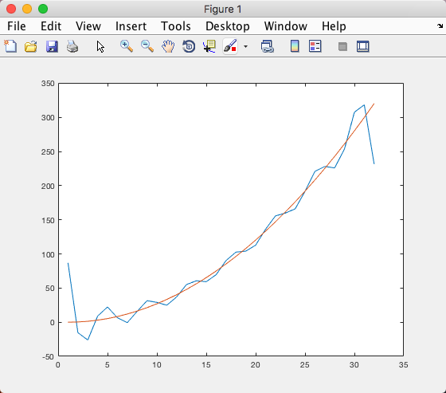

figure 2(y and $\hat{y}$):

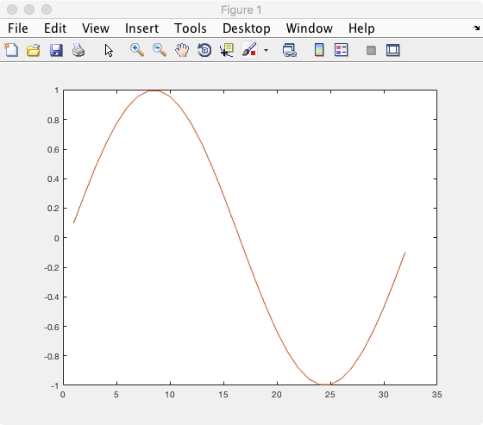

Problem 3.

Code:

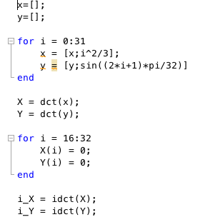

1. X = 613.768686069923

-535.841149514534

138.114216261511

-59.3449274209456

34.3590561210941

-21.2223992484599

15.1417256564255

-10.7155690842292

8.41152541306387

-6.38748024242396

5.29170234082456

-4.19179952818034

3.59175893815435

-2.92364096301509

2.56098449969019

0

0

0

0

0

0

0

0

0

0

0

0

0

0

0

0

0

Y = 1.07943856534510e-16

3.39940413550419

-4.87030390708512e-16

-2.03305677839866

6.86898891379504e-17

-0.480860950538638

1.45297784207247e-16

-0.222085269130132

2.65539973596442e-17

-0.127899094613052

1.70738134463007e-16

-0.0825225720043399

1.98443830466117e-16

-0.0570079917149157

4.41996116577035e-17

0

0

0

0

0

0

0

0

0

0

0

0

0

0

0

0

0

$\hat{x}$ = 0.187533777572611

0.221832728143558

1.06968778954588

3.05821451730264

5.62398355307324

8.35003486650247

11.7033647802826

16.2338824622476

21.6145906582690

27.1835692784543

33.0896305611452

40.0694241253843

48.1836611456106

56.6690559432202

65.2320874012509

74.6055228403487

85.3300330942114

96.7691294688807

108.130149464721

119.877968344402

133.052398324295

147.448725605501

161.794328029126

175.922395263026

191.315072878877

208.669895664396

226.326533032123

242.775312858306

259.816564798971

280.478279904247

302.863695482461

318.333441358105

$\hat{y}$ = 0.119128386685838

0.261614427407037

0.467362573481054

0.649619900889913

0.778046137971353

0.872472948766605

0.950778351823799

1.00084925438537

1.00191060246243

0.954259433317885

0.875197453420438

0.773168197804488

0.640596975896597

0.473396437605441

0.285070972245645

0.0942180961420271

-0.0942180961420269

-0.285070972245645

-0.473396437605441

-0.640596975896597

-0.773168197804488

-0.875197453420438

-0.954259433317885

-1.00191060246243

-1.00084925438537

-0.950778351823799

-0.872472948766605

-0.778046137971353

-0.649619900889914

-0.467362573481054

-0.261614427407038

-0.119128386685837

1. figure 1(x and $\hat{x}$):

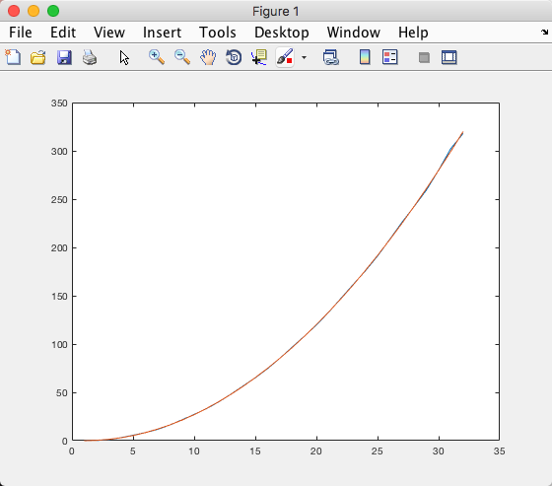

figure 2(y and $\hat{y}$):

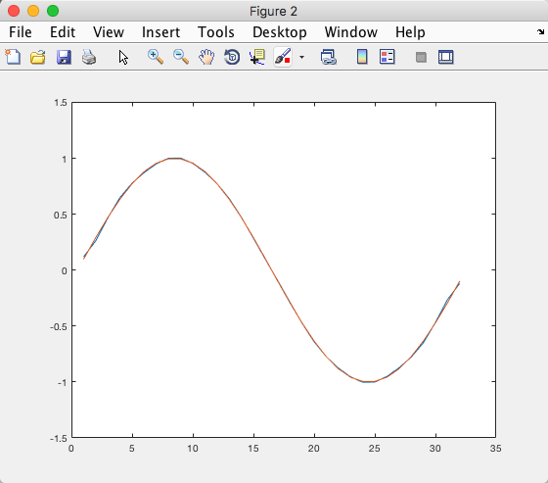

Problem 4:

Code:

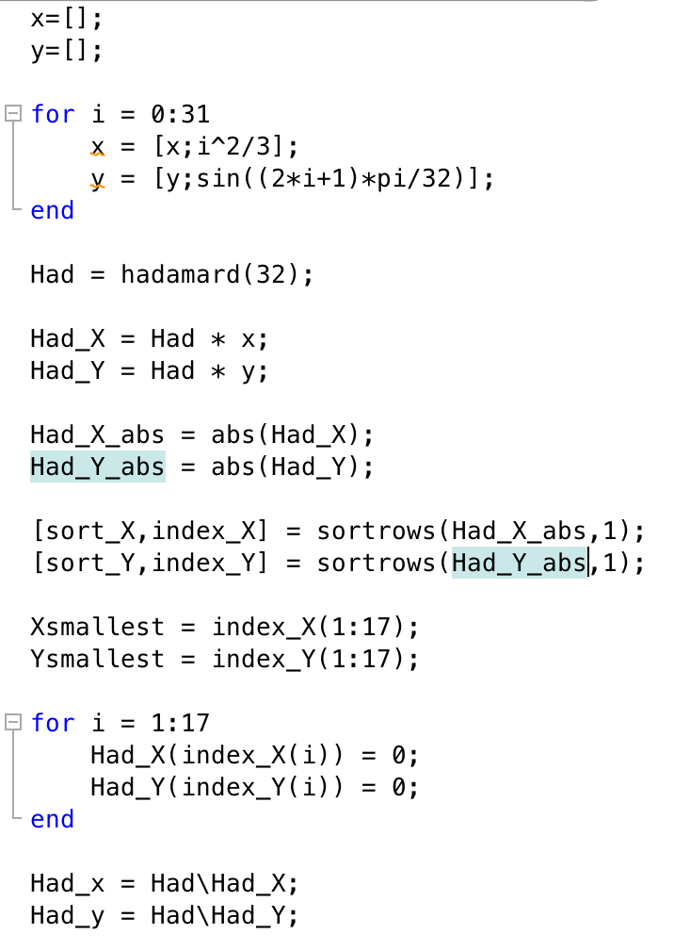

1. figure 1(x and $\hat{x}$):

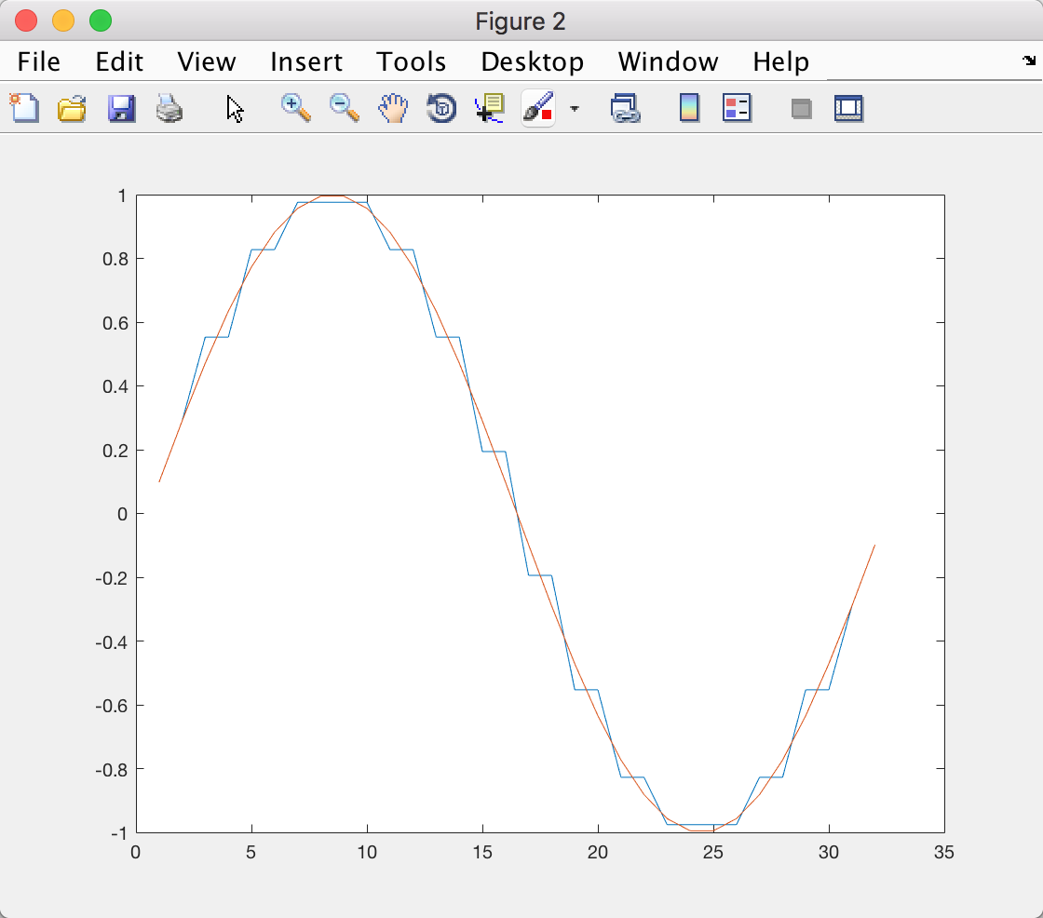

figure 2(y and $\hat{y}$):

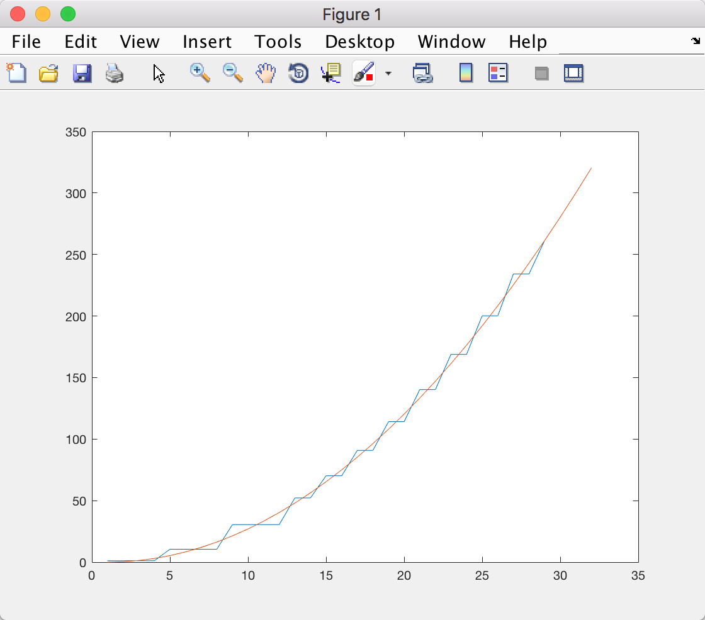

1. Code:

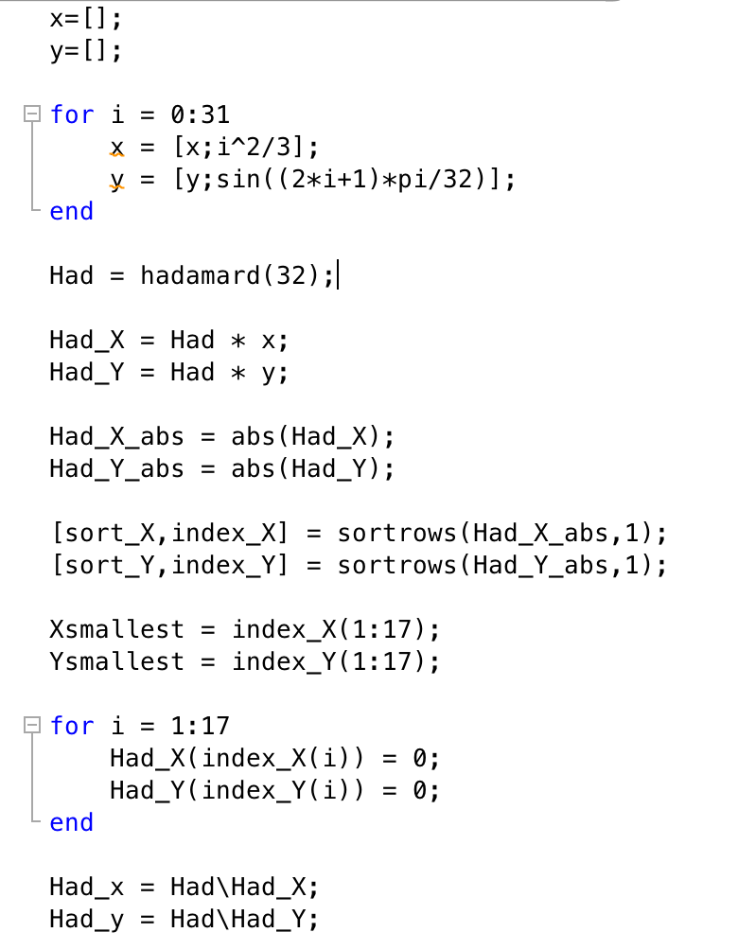

figure 1(x and $\hat{x}$):

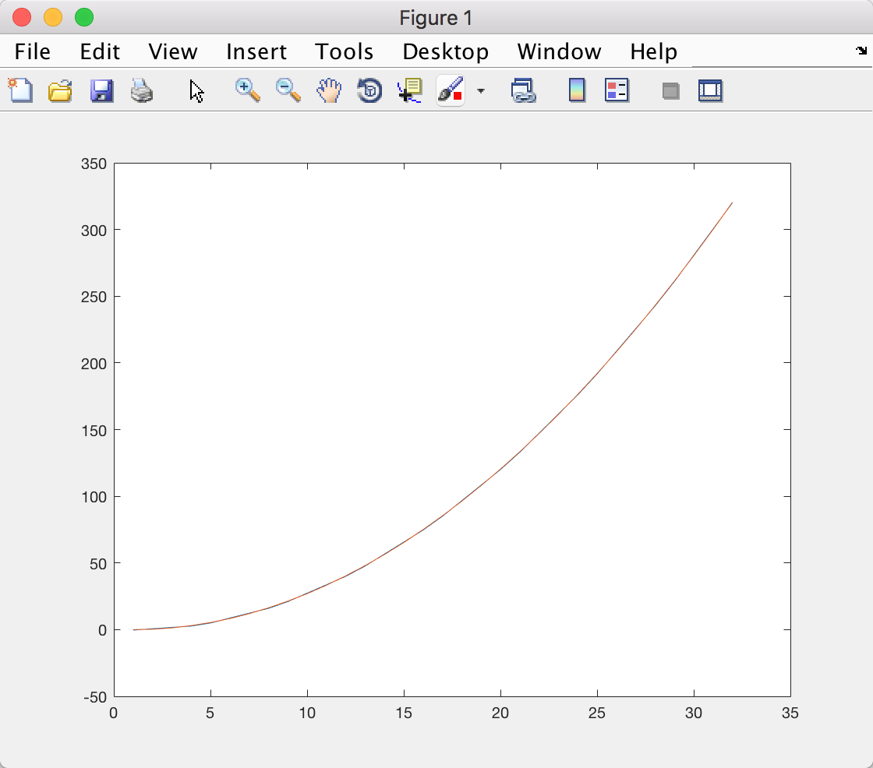

figure 2(y and $\hat{y}$):

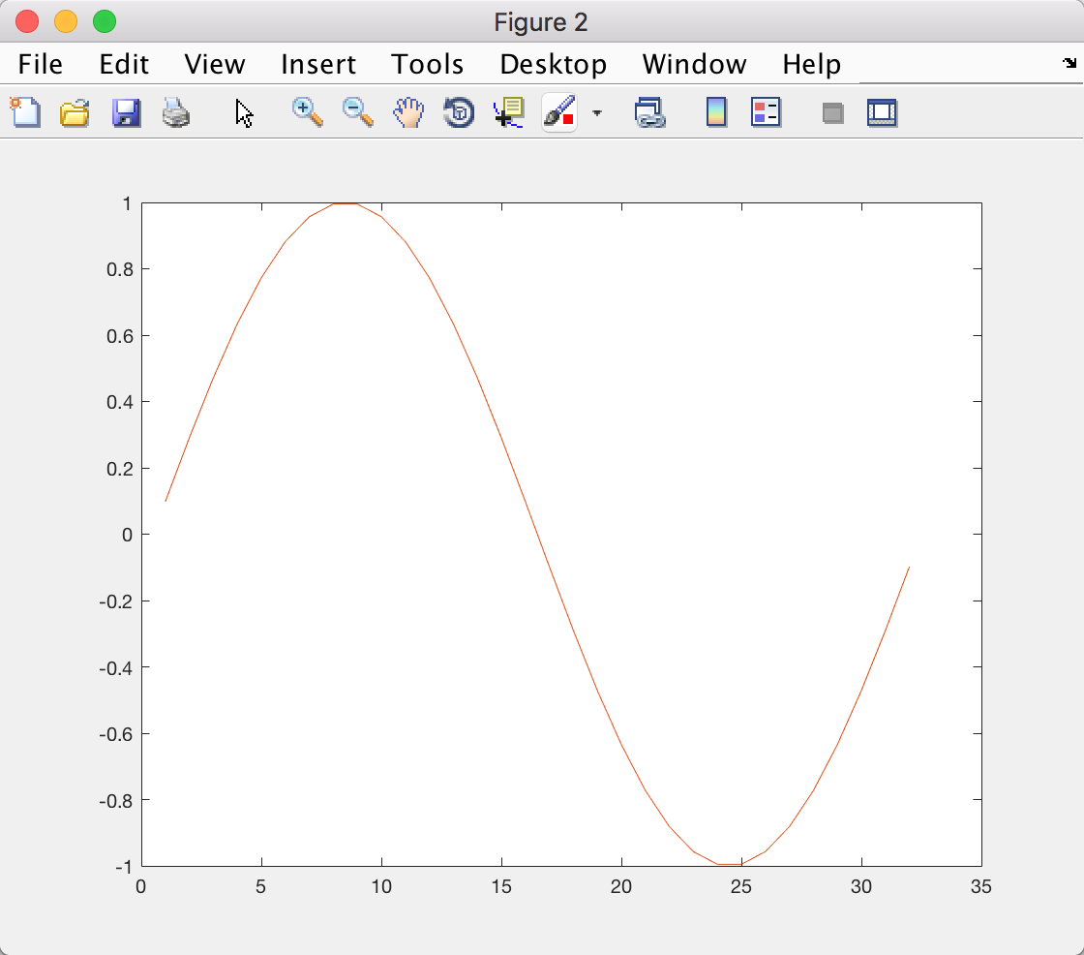

Problem 5:

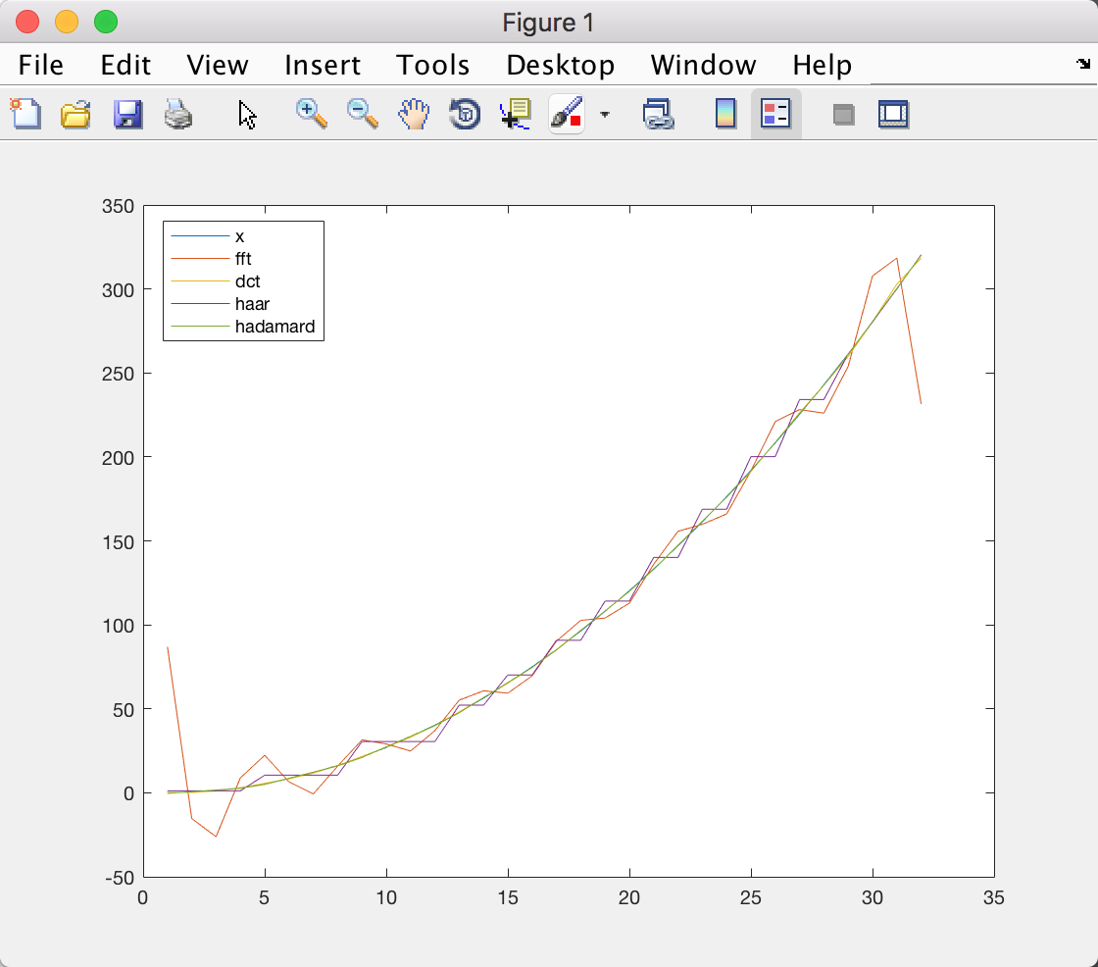

1. MSE of $\hat{x}$ of problem 2 = 599.1948

MSE of $\hat{x}$ of problem 3 = 0.5648

MSE of $\hat{x}$ of problem 4(a) = 30.8576

MSE of $\hat{x}$ of problem 4(b) = 0.1111

1. The $\hat{x}$ of Hadamard is the best reconstruction of x;
2. For all of the $\hat{y}$ s:

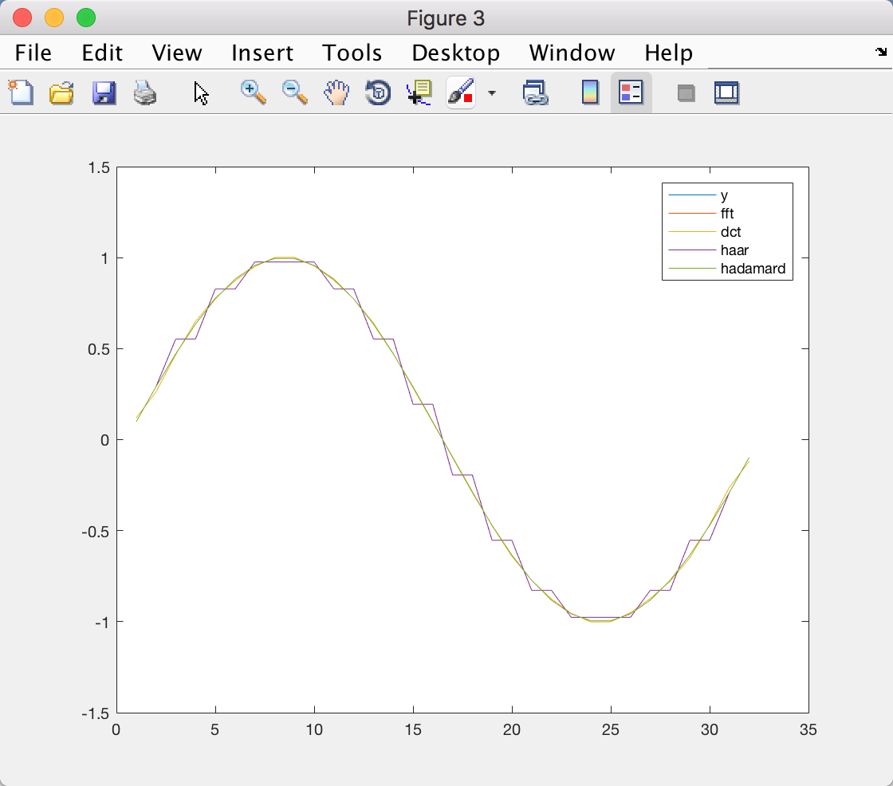

MSE of $\hat{y}$ of problem 2 = 9.5213e-33

MSE of $\hat{y}$ of problem 3 = 1.1764e-04

MSE of $\hat{y}$ of problem 4(a) = 0.0036

MSE of $\hat{y}$ of problem 4(b) = 8.7696e-32

The $\hat{y}$ of Fourier transform is the best reconstruction of y;